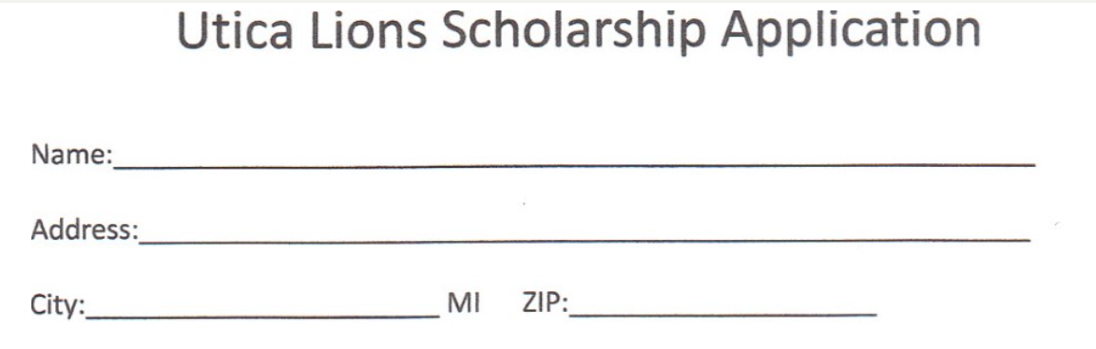
Phone: _________________________ Email: _________________________________________
High School: _________________
Please send this sheet with the items listed below to:
Utica Lions Club
C/O Patti Smith
PO Box 180040
Utica, Mi 48318
Information that is required:
College or University that you are accepted at _________________
Transcript of your school grades
A letter of recommendation from a teacher or school councilor
Will you be receiving other grants, and or scholarships? If so please list:

Please list Volunteer work and extracurricular activities

On a sperate page please provide approximately 200-word essay outlining your plans for your future and how this scholarship might help you reach these goals.

